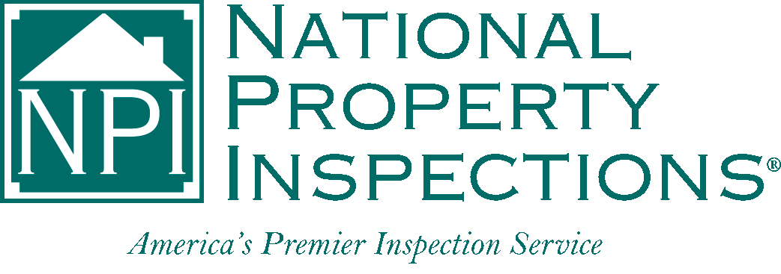Employee Non-compete Agreement

This covenant is entered into between ________________________________ of National Property Inspections,

*(Franchise Owner)*

hereinafter referred to as NPI, and ________________________________, hereinafter referred to as Employee.

(*Employee)*

Employee shall not, either directly or indirectly, for himself/herself or on behalf of, or in conjunction with, any other person, persons, partnership or corporation own, maintain, engage in, participate or have any interest in the operation of any other inspection service in any way similar to NPI.

The above provisions relating to interests in other inspection services shall not apply to ownership by Employees of outstanding securities of any corporation whose securities are publicly held and traded, provided that said securities are held by Employee for investment purposes only and that Employee’s total holdings do not constitute more than five percent of the outstanding securities of said corporation.

Employee further agrees that during the term of this agreement or any extension or renewals thereof, and for a period of two years thereafter, regardless of the cause of termination, Employee shall not divert or attempt to divert any business of, or any customers of NPI, or any existing referral sources, to any other competitive establishment, by direct or indirect inducement or otherwise; and shall not own or work in a property inspection business within a 50-mile radius of this NPI franchise operation.

Employee shall not, during the term of this agreement or after its termination or nonrenewal, communicate or divulge to any other person, persons, partnership or corporation any information or knowledge concerning the methods of operation, promotion or sales used by NPI, nor shall Employee disclose or divulge in whole or in part any trade secrets of NPI.

Employee acknowledges that a violation of any covenant in the above paragraphs will cause irreparable damage to NPI, the exact amount of which may not be subject to reasonable or accurate ascertainment, and therefore, Employee does hereby consent that in the event of such violation, NPI shall as a matter of right be entitled to injunctive relief to restrain Employee, or anyone acting for or on behalf of Employee, from violating said covenants.

Employee represents and acknowledges that in the event of the termination of this Agreement for whatever cause, his/her experience and capabilities are such that he/she can obtain employment in business engaged in other lines or of a different nature than that of the operation of an inspection service and that enforcement of a remedy by way of injunction will not prevent him/her from earning a livelihood.

In the event that NPI brings suit to enforce any provision hereof, NPI shall be entitled to receive, in addition to any relief or remedy granted the cost of bringing such suit, including reasonable attorney’s fees.

____________________ _______________________________________

Date Franchise Owner

____________________ _______________________________________

Date Employee